EBSCO’s Archive Loyalty Program
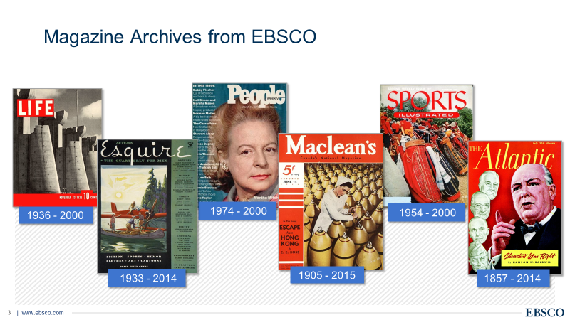
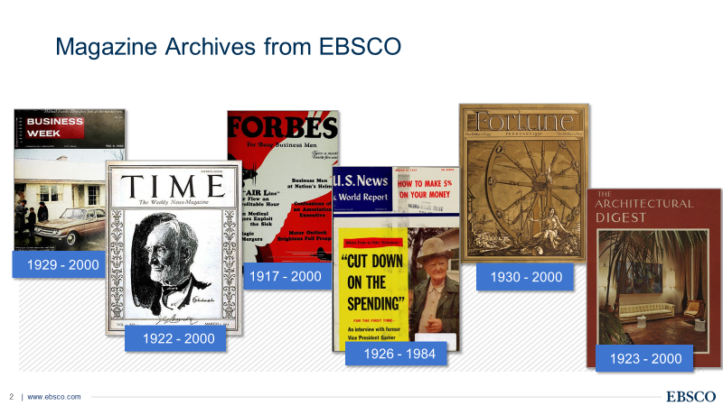
Here’s how the program works:
Buy 1 receive 35% off
Buy 2-3 receive 40% off
Buy 4-6 receive 45% off
Buy 7+ receive 50% off
There is an annual access fee equal to 2% of the purchase price of the archive, OR, you can inquire about a one-time fee up front.
Jaye Hess and Jackie Ullman
jhess@ebsco.com & jullman@ebsco.com

